Tensorflow notes

Machine Learning is divided into 3 parts
-Supervised Learning
-Unsupervised Learning
-reinforcement Learning

Supervised Learning - Labels
---Classification Problem -
---Regression Value - historical data

Unsupervised Data - Cluster the group of data
Need Domain knowledge

Reinforcement Learning - Trial and Error
-Agent -Environment -Actions
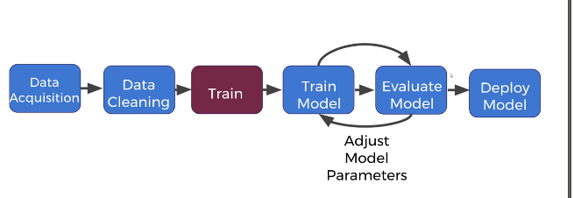
Data acquisition -
Data Cleaning - Most of the time split

Neural Networks

-Neurons and activaton Functions
-Cost Functions
-Gradient Descent
-Backpropogation

